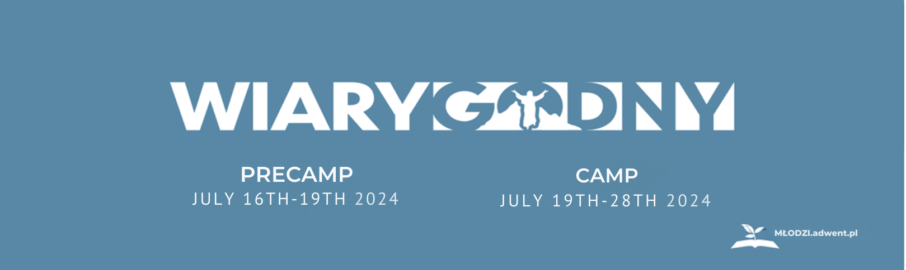

Kindly find some financial information about the upcoming camp.

Where: Ośrodek Polubie, Zatonie – Lubieszewo, k. Złocieńca
When: PreCamp July 16th-19th 2024, Camp July 19th-28th 2024
Main Speaker: TY GIBSON
Program: Besides the traditional and known Polish program, there will be a variety of workshops and activities FULL IN ENGLISH! More information coming soon…

Prices:
Tent/camper:
Adult | 30 zł/day
Students (13-25) | 25 zł/day
Kids (3-12) | 19 zł/day
Kids up to 3 years old | free

Additional costs:
Pitching the tent (S/M/L) | 0/9/16 zł/day
Setting up a caravan (up to 5m/ more than 5m) | 26/40 zł/day
Setting up a camper | 40 zł/day
Setting up an extension | 10 zł/day
Private electricity | 2 zł/kWh or 20 zł/day
Dog or cat | 10 zł/day
Parking (meadow/center’s parking/next to tent) | 5/10/17 zł/day
Group room | 40 zł/day
Registration fee | 25 zł + 8 zł/day (kids and youth -50%)

Additional information:
- For group room reservations, please call +48 22 31 31 431
- Additional rooms: There are but a few of them. If you need a room due to health or family situation, please fill in the form: https://forms.gle/EKbaBageicbjSCyK6
DISCLAIMER: Filling in the form is NOT a booking reservation and does not guarantee accommodation in a room!
- Renting tents: more information coming soon.
- If you need financial support, let us know by mail: mlodzi@adwent.pl

Head coordinator,
Alicja Bylina

