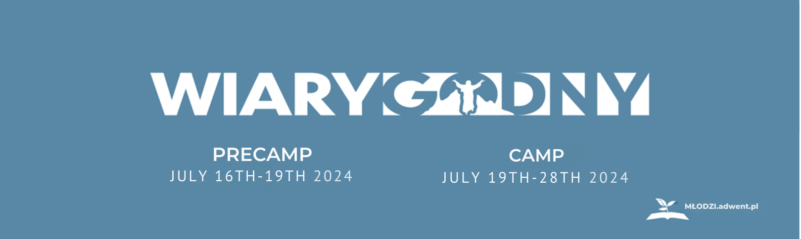

Workshops and activities list that you can choose from during the summer camp (19th-28th).

ATTENTION: Some of the bilingual workshops may need a previous reservation. Soon we will have detailed information.
- Workshops and Activities (EN): These workshops will be led in English only.
- TY GIBSON’s workshops and sermons (Translation to Polish)
- Baptismal Class
- Dating & Marriage
- Discovery Bible Studies
- Hot Topics – Q&As’ Panel
- Job Finder – Best tips to optimize your LinkedIn account and CV
- Personal finances
- TRC – Applications & Troubleshooting
- Worship Evenings – Praising & Learning from God
- Leader-Focus Workshops (19th-21st): The following blocks are focused on leadership development. If you are not a leader but would like to become one or learn about leadership and plans feel free to join.
- How to lead Bible studies and give Bible lessons?
- How to lead group services & programs?
- Networking
- Project Preparations for 2025 (Planning, Presenting, & Finances)
- Bilingual workshops and activities: These include everyone in the camp with limited or no language barrier for participants.
  - “The Voice” Zatonie
  - Charity Auction
  - Charity Run
  - Cooking Workshops
  - Market Day
  - Music Concerts
  - Retro Songs Evening
  - Sports
  - Vesper Prayer at the beach

